POST LIVER TRANSPLANT PATIENT FAMILY EDUCATION


PERSONAL HYGIENE
- Daily bath with antiseptic bath lotion (chlorhexidine scrub)
- Follow hand hygiene
- Nails to be cut short
- Moisture you skin
- Brush teeth twice daily, rinse your mouth after every meal
- Wash hands before and after food
- Wash hands before and after using wash room

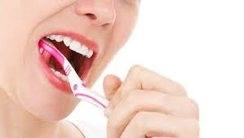

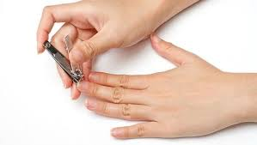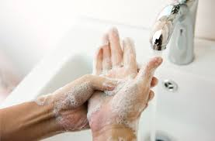

EXERCISE

- Daily exercise to keep your muscles strengthened

- Daily walking morning and evening (30-40mts/day)

- Triball exercise (spirometry)

- Avoid strenuous activity for 3 months

- Driving vehicle after 6 weeks

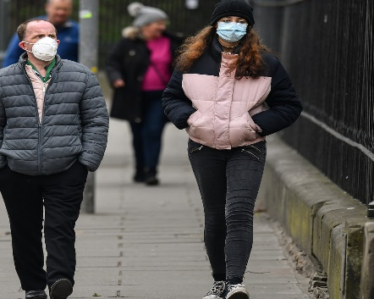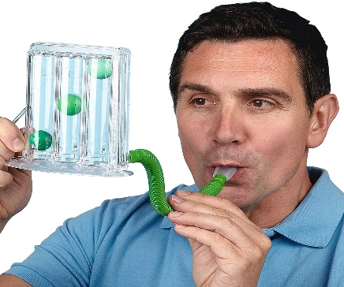

DIET AND NUTRITION
- Eat enough calories and protein to heal from surgery, protein is found in meats, poultry, fish, egg, paneer, pulses, etc.
- Follow good food safety to prevent food borne illness
- Consume only home cooked food
- Fresh fruits and vegetables need to be cleaned and rinsed in warm water.
- Wash hands frequently when working with food, avoid cross contamination
- Drink from safe water supplies after boiled & cooled for 5mts.
- Avoid fast food and junk foods from outside

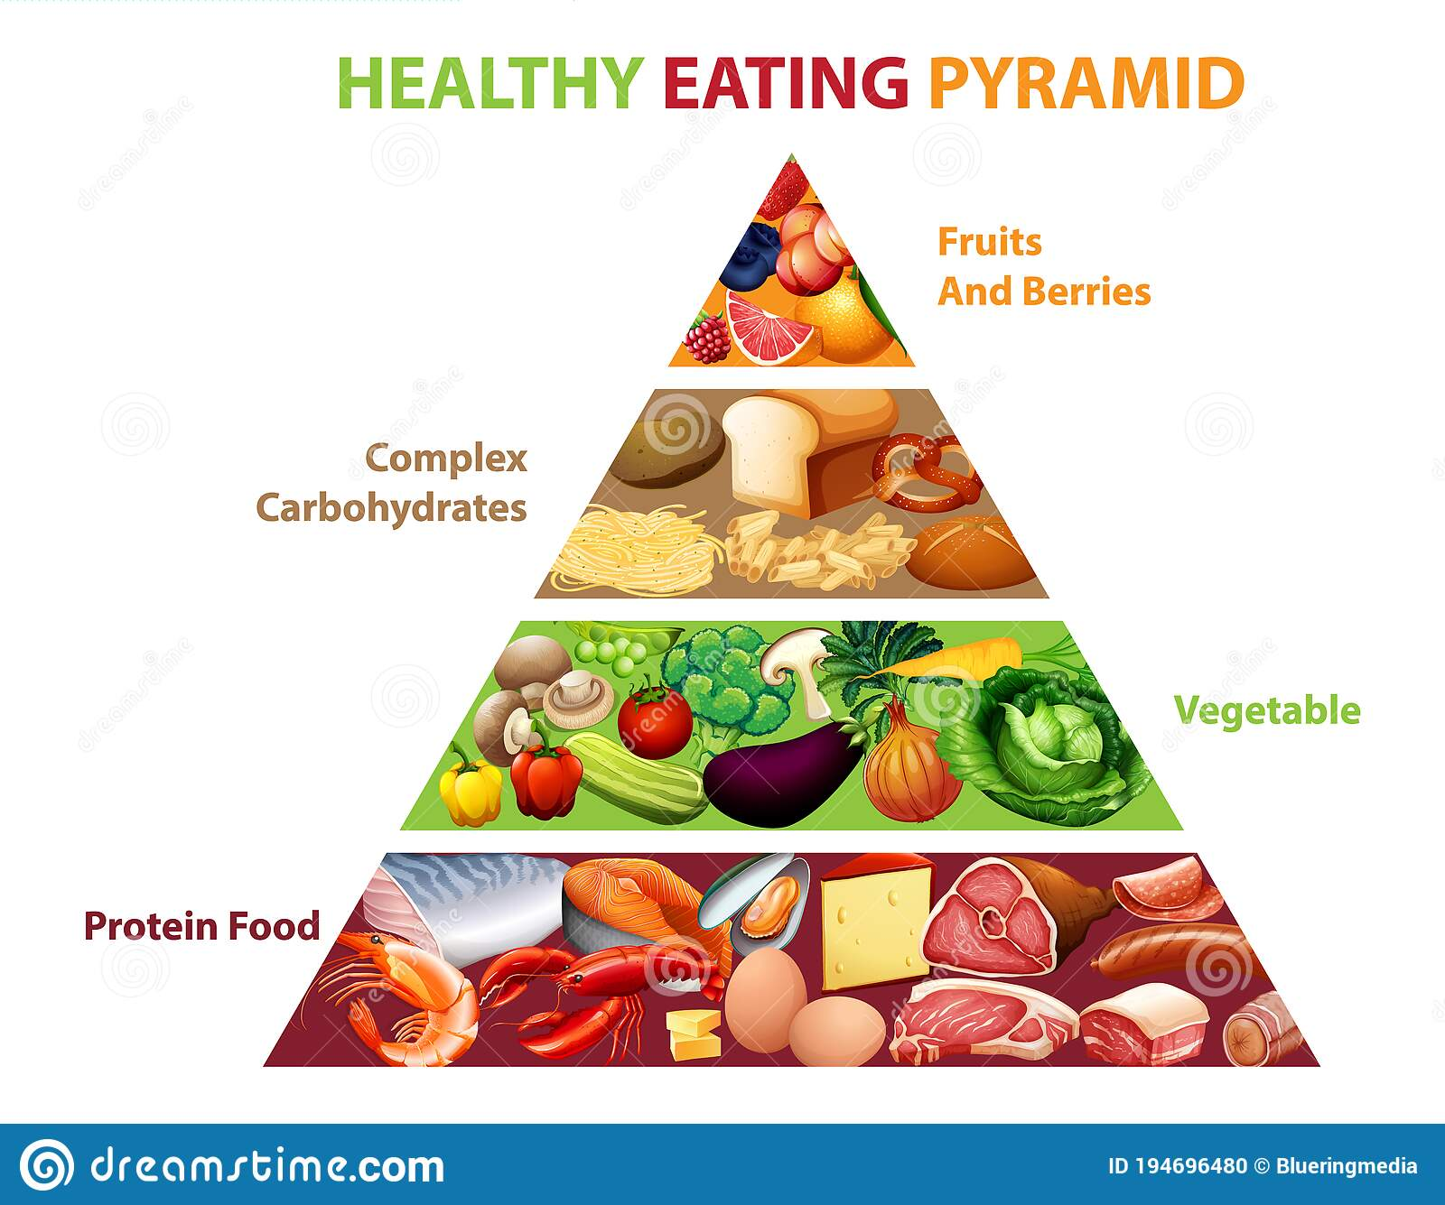

WOUND CARE

- Dry the surgical site with gauze after taking bath
- Examine the surgical site for oozing, redness, warmth and colour change.
- If any of the above is observed consult your doctor
- If drain tube or colobag present at discharge, empty it every day morning and measure the quantity. Note the colour, and consistency.

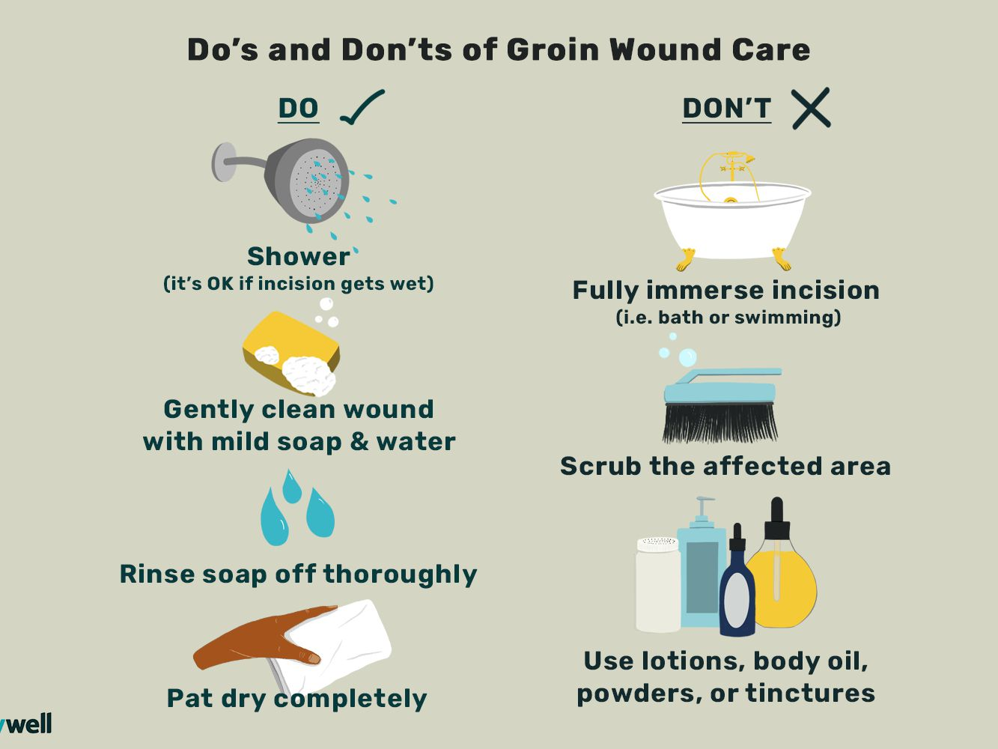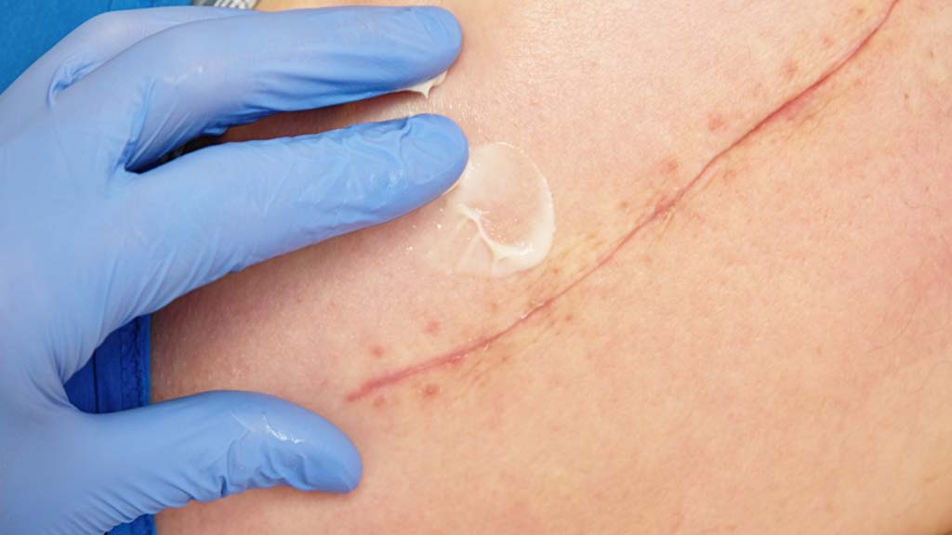
Use gloves
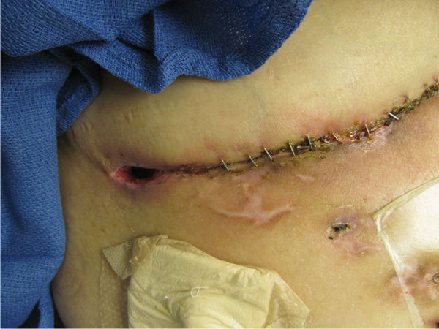
Wound infection

MEDICATION

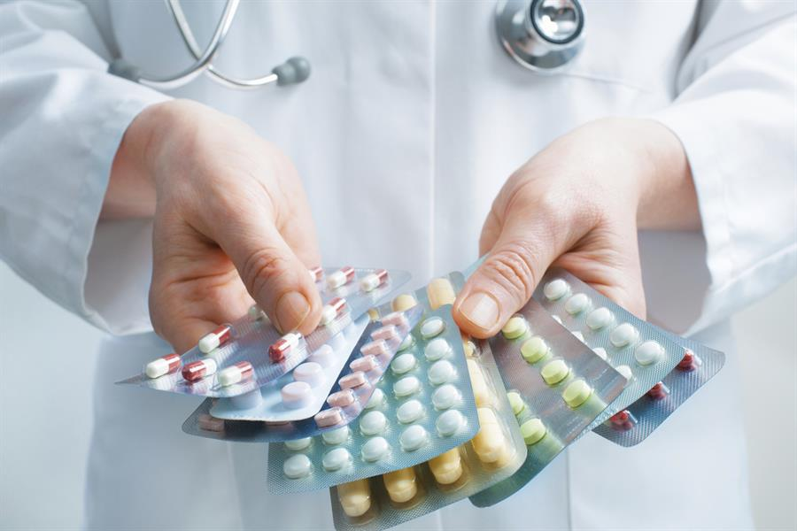
Prograf (Tacrolimus)
- It should be taken at 8am and 8pm without fail
- While taking this tablet, take nothing by mouth 1 hour before and 1 hour after.
- Do not skip the dose
- Do not take double the dose
- Tacrolimus blood levels, sample to be drawn before the morning dose and not less than 11 hours gap between the last dose and the sampling time
- Avoid grape fruit and chocolates; it interacts with the serum tracrolimus levels.
- Watch for urea, creatinine and WBC levels.
- Watch for fever, decreased urine ouput, abdomen pain pus discharge if any consult your Doctor without any delay.

(MMF)
- Watch for fever, loose stools. If any consult your doctor and follow advice
Ecospirin (Aspirin)
- Know your platelets and ensure that the levels are normal, if its less than 50000 consult your doctor and follow orders.
- Ecosprin should be taken after food only.
Wysolone
- Can cause high sugar levels
- Check blood glucose levels atleast once a day on fasting
Insulin
- If diabetalogist opinion is taken follow the advice and don’t skip insulin

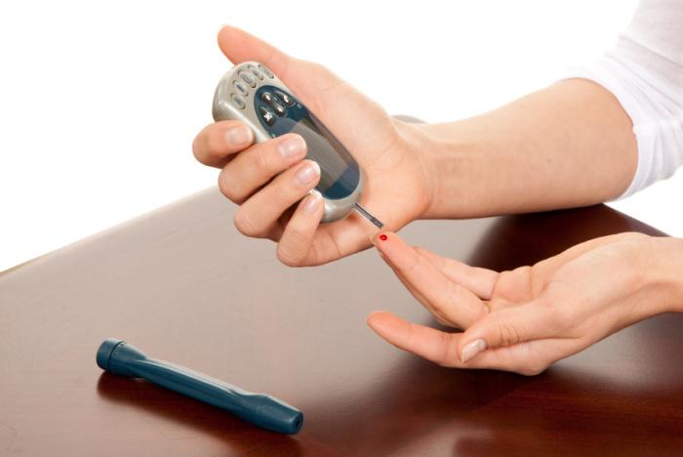

All the medications to be taken at the prescribed time and frequency to avoid gastro-intestinal disturbance, and to get a beneficial therapeutic effect.
GENERAL INSTRUCTION
- Stay away from people who are sick.
- Wash your hand often and use hand sanitizer
- Always tell your doctor if you get a cold sore throat, rash or small blisters on your body
- Tell your doctor about sore throat, white coating on your tongue
- Learn signs of infection (fever, abdomen pain, pus discharge from wound)
- Stay away from crowds and rooms with poor ventilation. Make sure vents in the home are cleaned often
- Do not swim in any lakes or community pools during the high-risk period.
- Be sure to follow your nutrition plan.
- Stay away from houseplants or garden soil and pets during the high risk period
- Make taking your medicine part of your daily routine, just like eating and sleeping
- Avoid vaccination / boosters, without consulting doctors.
Dr Tanuja Mallik
Director & Head
Liver Transplant Anesthesia and Critical care
Venkateshwar Hospital
Dwarka New Delhi
For more patient and caregiver education material visit
https://livertransplanthelp.com/

Our wish for you is that, your dreams stay big and your worries stay small. You never need to carry more than you can hold. With the new life comes new strength have a joyful life.

